ELMECO&WoTEAM proceedings manuscript sample (A4 size)

Oleksadr Boiko
ORCID: 0000-0001-7759-6269 / Lublin University of Technology – ROR: https://ror.org/024zjzd49
Henryka D. Stryczewska
ORCID: 0000-0003-0850-7108 / Lublin University of Technology – ROR: https://ror.org/024zjzd49

*Corresponding author: O. Boiko, o.boiko@pollub.pl

Abstract
Begin the abstract two lines below authors’ names and addresses. The abstract summarizes key findings in the paper. It is a paragraph of 250 words or less. The abstract section should be self-contained (i.e., no numerical references) and substantive in nature, presenting concisely the objectives, methodology used, results obtained, and their significance. Avoid the use of equations and complex fractions.
For the keywords, select up to 8 key terms for a search on your manuscript's subject.

Keywords: Times Roman, image area, acronyms, references

Introduction
Begin the Introduction two lines below the keywords. The manuscript should not have headers, footers, or page numbers. It should be in a one-column format. References should be listed at the end of the manuscript and numbered consecutively in the order of their citation in the text. In-text citations can use superscript or bracketed reference numbers.

Margins
Please use the following margins: top and bottom – 2.54 cm (1 in.), left and right – 1.93 cm (0.76 in.)

Fonts
Below are presented the font sizes and highlighting in an abstract. These font "styles" are contained within this abstract template. Use Times New Roman font style to avoid font errors.
To avoid font-related errors, please use Times New Roman for the main text and Arial for headings and captions.

Formatting of manuscript components

Title
Center the paper title at the top of the page in 16-pt. bold. Only the first word, proper nouns, and acronyms are capitalized. Keep titles brief and descriptive. Spell out acronyms unless they are widely known. Avoid starting with articles or prepositions, e.g., “The study of … ,” or, “On the ….”

Author affiliations
The author list is in 12-pt. regular, centered. Omit titles and degrees such as Dr., Prof., Ph.D., etc. The list of affiliations follows. Each author's affiliation should be clearly noted. Use superscript numerals or letters to denote connection between authors and affiliations.

Section headings
Section headings are 11-pt. bold capitals, centered. Sections numbers have whole numbers, e.g., 1, 2, 3… Don't number the “Introduction”, “Acknowledgements” and “References.” Headings often used are: 1. Methodology, 2. Data, 3. Results, and 4. Conclusions.

Subsection heading
Subsection headings are left-justified, 10-pt. bold. Capitalize the first word, acronyms, and proper nouns.

Text
Text is 10 point and justified. Each sentence ends with a period and a single space before the next sentence.

FIGURES and tables

3.1. Figures
Positioning Figures and Tables: Place figures and tables at the top and bottom of columns. Avoid placing them in the middle of columns. Figure captions should be below the figures; table heads should appear above the tables. Insert figures and tables after they are cited in the text. Use the abbreviation “Fig. 1”, even at the beginning of a sentence.
Figure Labels: Use 9 point Times New Roman / Arial / Calibri for Figure labels. Try to keep the text font the same across all pasted figures. Use words rather than symbols or abbreviations when writing Figure axis labels to avoid confusing the reader. As an example, write the quantity “Magnetization”, or “Magnetization, M”, not just “M”. If including units in the label, present them within parentheses. Do not label axes only with units. In the example, write “Magnetization (A/m)” or “Magnetization {A[m(1)]}”, not just “A/m”. Do not label axes with a ratio of quantities and units. For example, write “Temperature (K)”, not “Temperature/K.”
Figure Requirements: Authors are requested to send all drawings used in the article in additional files. Create a separate file for each image. Images should be submitted in a bitmap format (.jpeg/.png) or/and in a vector format (.pdf, .svg). Each file must be saved according to the number in the original article, e.g.: FIG1.JPG or FIG1.PDF. Bitmap illustrations must be “flattened”, which means no additional layers, for example, covering old descriptions.
All photographs and figures (both colour and greyscale) must have a resolution of at least 300 dpi at their final printed size. To ensure sharp print quality, please refer to the required width in pixels for A4 publications – minimum 2500 px wide. Elements created in the Editor must be grouped and, ideally, saved as a single image before being pasted into a text.
Do not use tables for page layout or image positioning. Tables must be used exclusively for structured tabular data. Do not insert figures, photos, or diagrams into table cells to arrange them on the page-place figures directly in the main text stream as standalone paragraphs. The illustration should be a single image no wider than 17 cm. A caption should be placed beneath the illustration, and its source should be indicated (Fig. 1 and Fig. 2), for example:

Figure 1. Selected frequency dependencies of nanofluid samples of: impedance Z (a), phase shift angle θ (b);
own elaboration based on [15]
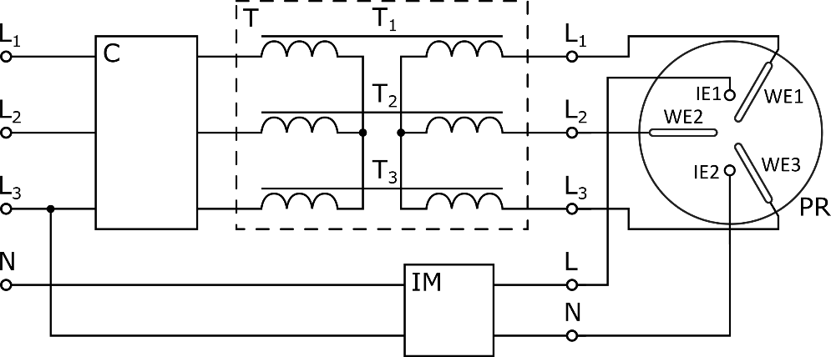
Figure 2. ZF-10 plasma reactor power supply: C – AC/DC/AC converter, T – matching transformers, IM – ignition module, PR – plasma reactor, IE – ignition electrodes, WE – working electrodes [15]
Every image should have an alternative description. A separate list of illustrations and a separate list of diagrams should be sent to the organizers; the list of illustrations should include the figure number and the alternative description, and the same procedure should be followed for the diagrams, including the diagram number and the description.
Regardless of the lists in Word, you must insert an alternative description for figures. Select the figure with the mouse cursor and right-click; then select the command: ‘Show alternative text’. A window will appear in the right-hand menu/bar where you can enter the alternative description, with the option to generate a ready-made description, which you should check. We recommend that you prepare the alternative descriptions yourself.
Alternative descriptions should summarize what is shown in the figure in 1–2 sentences, but must not simply repeat the caption. If a detailed description is provided below the figure, it is sufficient to state: ‘A detailed description of the figure is provided below’.

3.2. Tables
Tables must have a clean and simple structure, consisting of a clear, visible header (usually the first row and/or the first column) followed by data cells.

Keep cell structure simple: Avoid merging cells (both horizontally and vertically) or nesting tables within other tables, as this disrupts the reading order and layout conversion.

No blank cells: Do not leave any cells completely empty. If no data is available for a cell, insert a half-stop (a period/dot) or write “N/A” (or "Not applicable").

Data only: Use tables exclusively for structured data, never for page design or positioning graphics. Tables should have a simple layout: a visible header (usually the first row and/or the first column) and data. Cells should not be left blank; if they contain no data, a half-stop should be inserted.

Table 3. Critical parameters of type I and II superconductors
Parameter | Symbol | Value
critical temperature | T_{c} | Temperature below which a superconductor exhibits superconductivity at zero critical field strength and zero critical current.
lower critical magnetic field strength | H_{c1} | Magnetic field strength at which the first fluxion enters the volume of a type II superconductor, causing a departure from ideal diamagnetism.
upper critical magnetic strength | H_{c2} | Maximum magnetic field strength below which a type  II superconductor is in the mixed state.
critical current | I_{c} | Maximum direct current that can be considered to flow in a superconductor without resistance.

Mathematical Equations
Use common fonts like Times New Roman, Arial, Calibri in your math equations. A math reference in a paragraph sentence such as is not numbered. The steps of a mathematical argument can be numbered using a right-aligned tab for clarity, for example
α = (1)
and
ρ=. (2)
Variables and formulas appearing in the text should be entered using the computer keyboard or the ‘character map’ – do not insert variables using the built-in equation editor (with the exception of variables that have both superscript and subscript markers).
Equations should be typed within the text, centered, and should be numbered consecutively throughout the text. Their numbers should be typed in parentheses, flush right. Equations should be referred to in text, e.g. (1), except at the beginning of a sentence: “Equation (1) is ...”. All symbols appearing in equations have to be defined in the text, before or just after the equation. Please keep the same font in the formulas and text.
If the symbols are written in Times New Roman use italic fonts. Symbols of vectors and matrices should be written in bold fonts. Do not italicize Capital Greek fonts and mathematical symbols like e.g.: the derivative symbol d, max, min, etc. The indices of symbols that are indices themselves should be written in a clear manner.

Unit symbols, abbreviations
Define abbreviations and acronyms the first time they are used in the text, even after they have been defined in the abstract. Abbreviations such as IEEE, SI, MKS, CGS, sc, dc, and rms do not have to be defined. Do not use abbreviations in the title or heads unless they are unavoidable. Si units are recommended for use in formulas, drawings and tables., for example the SI unit for magnetic field strength H is A/m. Apply the center dot to separate compound units, e.g., “N·m. Do not mix complete spellings and abbreviations of units: “Wb/m²” or “webers per square meter,” not “webers/m².” Spell units when they appear in text: “...a few henries…”, not “...a few H…”. Use a zero before decimal points: “0.25,” not “.25.” Use “cm³,” not “cc.”. Unit symbols, SI prefixes as well as abbreviations should be written in accordance with the IEEE standard – http://www.ewh.ieee.org/soc/ias/pub-dept/abbreviation.pdf

hyperlinks
How to paste hyperlinks correctly into text and references:
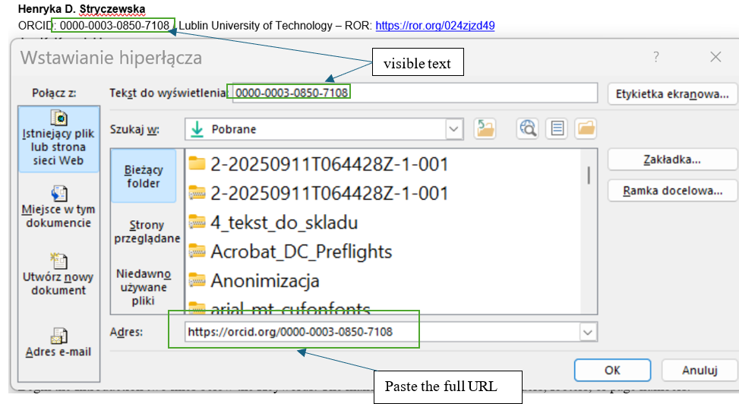

Conclusions
A conclusion might elaborate on the importance of the work or suggest applications and extensions. Although a conclusion may review the main points of the manuscript, do not replicate the abstract as the conclusion.

Acknowledgements
Use this section to identify people who have aided the authors in accomplishing the work presented and to acknowledge sources of funding. Include grant numbers and the full name of the funding body.

References
- G. O. Young, “Synthetic structure of industrial plastics (Book style with paper title and editor),” in Plastics, 2nd ed. vol. 3, J. Peters, Ed. New York: McGraw-Hill, 1964, pp. 15–64. DOI: 10.1109/TNANO.2026.3675650
- W.-K. Chen, Linear Networks and Systems (Book style). Belmont, CA: Wadsworth, 1993, pp. 123–135. DOI: 10.1109/TNANO.2026.3675650
- H. Poor, An Introduction to Signal Detection and Estimation. New York: Springer-Verlag, 1985, ch. 4.
- B. Smith, “An approach to graphs of linear forms (Unpublished work style),” unpublished.
- E. H. Miller, “A note on reflector arrays (Periodical style—Accepted for publication),” IEEE Trans. Antennas Propagat., to be published.
- J. Wang, “Fundamentals of erbium-doped fiber amplifiers arrays (Periodical style—Submitted for publication),” IEEE J. Quantum Electron., submitted for publication.
- C. J. Kaufman, Rocky Mountain Research Lab., Boulder, CO, private communication, May 1995.
- Y. Yorozu, M. Hirano, K. Oka, and Y. Tagawa, “Electron spectroscopy studies on magneto-optical media and plastic substrate interfaces(Translation Journals style),” IEEE Transl. J. Magn. Jpn., vol. 2, Aug. 1987, pp. 740–741 [Dig. 9th Annu. Conf. Magnetics Japan, 1982, p. 301].
- M. Young, The Techincal Writers Handbook. Mill Valley, CA: University Science, 1989.
- J. U. Duncombe, “Infrared navigation—Part I: An assessment of feasibility (Periodical style),” IEEE Trans. Electron Devices, vol. ED-11, pp. 34–39, Jan. 1959.
- S. Chen, B. Mulgrew, and P. M. Grant, “A clustering technique for digital communications channel equalization using radial basis function networks,” IEEE Trans. Neural Networks, vol. 4, pp. 570–578, July 1993.
- R. W. Lucky, “Automatic equalization for digital communication,” Bell Syst. Tech. J., vol. 44, no. 4, pp. 547–588, Apr. 1965.
- S. P. Bingulac, “On the compatibility of adaptive controllers (Published Conference Proceedings style),” in Proc. 4th Annu. Allerton Conf. Circuits and Systems Theory, New York, 1994, pp. 8–16.
- G. R. Faulhaber, “Design of service systems with priority reservation,” in Conf. Rec. 1995 IEEE Int. Conf. Communications, pp. 3–8.
- W. D. Doyle, “Magnetization reversal in films with biaxial anisotropy,” in 1987 Proc. INTERMAG Conf., pp. 2.2-1–2.2-6.
- G. W. Juette and L. E. Zeffanella, “Radio noise currents n short sections on bundle conductors (Presented Conference Paper style),” presented at the IEEE Summer power Meeting, Dallas, TX, June 22–27, 1990, Paper 90 SM 690-0 PWRS.
- J. G. Kreifeldt, “An analysis of surface-detected EMG as an amplitude-modulated noise,” presented at the 1989 Int. Conf. Medicine and Biological Engineering, Chicago, IL.
- J. Williams, “Narrow-band analyzer (Thesis or Dissertation style),” Ph.D. dissertation, Dept. Elect. Eng., Harvard Univ., Cambridge, MA, 1993.
- N. Kawasaki, “Parametric study of thermal and chemical nonequilibrium nozzle flow,” M.S. thesis, Dept. Electron. Eng., Osaka Univ., Osaka, Japan, 1993.
- J. P. Wilkinson, “Nonlinear resonant circuit devices (Patent style),” U.S. Patent 3 624 12, July 16, 1990.

Please use only the citation style specified in the example above.

Please provide DOI information if the bibliographic item has one.

